**Store Product sales Analysis**

A store is interested in determining the associations between items purchased from the Health and Beauty Aids department and the Stationery Department. The store chose to conduct a market basket analysis of specific items purchased from these two departments. TRANSACTIONS contains information about over 400,000 transactions made over the past three months. The following 17 products are represented in the data set: bar soap, bows, candy bars, deodorant, greeting cards, magazines, markers, pain relievers, pencils, pens, perfume, photo processing, prescription medications, shampoo, toothbrushes, toothpaste, and wrapping paper.

|  |  |  |  |
| --- | --- | --- | --- |
| **Name** | **Model Role** | **Data Type** | **Description** |
| STORE | Ignore | Numeric | Identification number of the store |
| TRANSACTION | Ident | Numeric | Transaction identification number |
| PRODUCT | Target | Categorical | Product purchased |
| QUANTITY | Ignore | Numeric | Quantity of this product purchased |

1. a.), b.), c.)

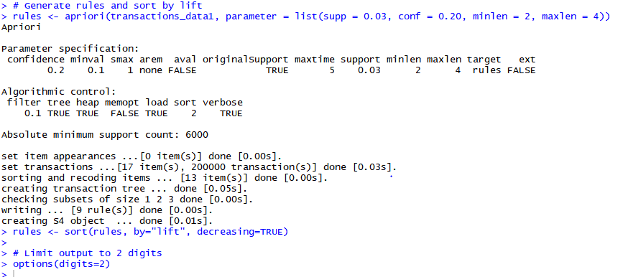

d.)

Only nine rules exist so inspect(rules [1:10]) will show out of bound error.  
Therefore running inspect(rules [1:9]).

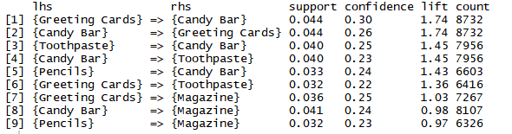

1. Remove duplicates



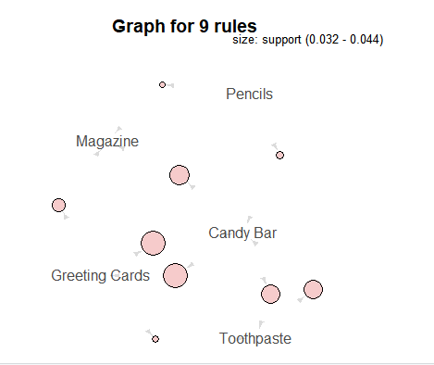

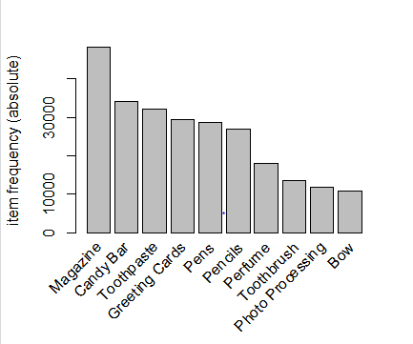

1. a.) Highest lift value is 1.74. The rules that have max lift.

{Greeting Cards} => {Candy Bar}

{Candy Bar} => {Greeting Cards}

b.)Lift is calculated using the following formula:

Lift=confidence of rule/support for the consequent=P(Consequent|Antecedent)/P(Consequent)

Where Consequent is RHS and Antecedent is LHS

c.)Interpreting first five rules.

[1] {Greeting Cards} => {Candy Bar} Suggest candy bars to people who bought greeting cards as most people who buy greeting cards also tend to buy candy bars.

[2] {Candy Bar} => {Greeting Cards} Suggest greeting cards to people who bought candy bars as most people who buy candy bars also tend to buy greeting cards.

[3] {Toothpaste} => {Candy Bar} Suggest candy bars to people who bought toothpaste as most people who buy toothpaste also tend to buy candy bars.

[4] {Candy Bar} => {Toothpaste} Suggest toothpaste to people who bought candy bars as most people who buy candy bars also tend to buy toothpaste.

[5] {Pencils} => {Candy Bar} Suggest candy bars to people who bought pencils as most people who buy pencils also tend to buy candy bars.

d.)There is no redundancy. We can access these rules as a decision maker. Like advertising Candy bar, magazine and toothpaste to people who buy Greeting cards. Advertizing greeting card, toothpaste and magazine to people who buy candy bars etc.